Sylvester Okwunodu Ogbechie

**Enwonwu, Ben C. (1917-1994)**  971 words

Benedict Chukwukadibia Enwonwu was a pioneer African modernist and the first African transnational artist to gain global visibility, having had his art exhibited in Europe, Africa, USA, and also in Asia well before 1950. Enwonwu was born in Onicha in Eastern Nigeria in 1917 and grew up in a cosmopolitan market town that was a center of indigenous Igbo culture and British colonial control. The origins of Enwonwu’s art lie in the complex historical and cultural environments from which the artist emerged. A sculptor and painter, his art was a complex amalgamation of British colonial culture and indigenous Igbo/African systems of representation that framed the artist’s early years. His father was a sculptor who produced both ritual and secular artworks for indigenous Onitsha society and Enwonwu was first introduced to the conceptual structures of Igbo aesthetics through his father’s practice. Throughout his life, Enwonwu described himself as a sculptor and used his father’s traditional tools of sculpture, mainly an adz, to produce his own works. Ben Enwonwu died in 1994 and left a legacy of significant art and notable critical interventions, which reflected his insistence on formulating a notion of African modernist practice that built on important indigenous styles and aesthetics. His various artworks, writings and commentary on the art of his time are among the most substantial of any modern artist in the global context.

Enwonwu began his formal art education in the Nigerian colonial educational system under Kenneth C. Murray with whom he studied from 1933 to 1937 and who exhibited the works of his pioneer students (including Enwonwu) in London in 1937. Upon graduation, Enwonwu taught for seven years in Nigerian secondary schools from 1938 culminating in a posting to Benin City from 1941 to 1944. In addition to his sustained study of European modes of representation during this period, Enwonwu digested the centuries old traditions of Edo art whose indigenous aesthetic frameworks he imbibed through apprenticeship with the master sculptors of the Benin royal guilds.

Enwonwu received a British government scholarship to study in the United Kingdom and moved there in 1944. He attended Goldsmiths College, and studied at Oxford’s Ashmolean Museum before completing his formal education at the Slade School of Fine Arts of the University of London where he studied art, obtained a post-graduate diploma in anthropology and presented the first in a series of well received exhibitions that eventually secured his fame as “Africa’s greatest artist”. However, the most significant development in Enwonwu’s art in this period was his adoption of the Onitsha-Igbo masqueradepantheon as a conceptual framework. From his initial representation of such masquerades in a 1949 painting, this imagery quickly became the core of a personal style.

The unique circumstances of Enwonwu’s career meant that he was subject to competing interests: on one hand, the British colonial order tried to claim the artist for its project of benevolent tutelage in the colonies, which sought to shape the colonial subject into a flag-carrying supporter of British imperialism. In contrast, Enwonwu’s African and African Diaspora audiences held up his international success as evidence of the capabilities of Africans freed from colonial domination. His work was inserted into a pan-African struggle for African emancipation from colonial rule, which saw the artist lauded by African anti-colonial nationalists, African American anti-segregationists, and Black British subjects, who all co-opted the artist as a major figure of global black aspiration.

The competing claims made on Enwonwu by these divergent constituencies constitute the principal conundrum of his adult career since they located the artist at the intersection of powerful yet contrasting impulses. Enwonwu resolved this conundrum by producing art in two distinct styles: in one style he favored the academic techniques he learned as a student at the Slade. In the other, he worked out a modernist and largely abstract style based on representations of numinous imagery, mostly of masquerades. The paintings and sculptures of Enwonwu’s late years extended his reconfiguration of indigenous aesthetics within a context of masquerade performances. These late works are unique for their aesthetic vision and conceptual sophistication.

Enwonwu’s most famous sculpture is titled *Anyanwu* (Rising Sun), a sculpture produced in 1955 right after he completed a commission for a sculpture of Queen Elizabeth II, whose unveiling in 1956 was widely reported in newspapers across the world. Several versions of *Anyawu* are located at the National Museum in Lagos, the United Nations Headquarters in New York, and the National Museum of Zimbabwe.

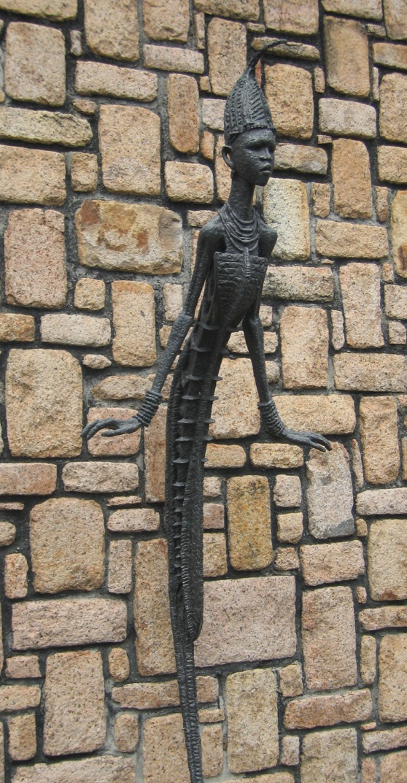

Ben Enwonwu, *Anyanwu*, bronze, 1956. Photograph © Sylvester Ogbechie

**List of Works:**

Enwonwu, Ben (1956). “Problems of the African artist today.” *Presence Africaine* (Paris), Nos. 8 – 10 (June – November), 174 – 178 (Enwonwu’s analysis of the problems of postcolonial African artists in the context of nationalism and independence struggles).

**References and further reading:**

“Enwonwu the Bohemian.” *West African Review*, August 1948: 909 (British press’ representation of Enwonwu as a modern artists in 1948).

Ogbechie, Sylvester Okwunodu (2008) *Ben Enwonwu: The Making of an African*

*Modernist,* Rochester: University of Rochester Press (a comprehensive analysis of Enwonwu’s career and intellectual engagements in the colonial and postcolonial era).

Ogbechie, Sylvester Okwunodu (2002), “Aesthetics and Artistic Identity in Modern

Nigerian Art.” *NKA: Journal of Contemporary African Art*, Numbers 16/17 (Fall/Winter), 24-31 (Analysis of Enwonwu’s career in relation to local and international discourses of modernism)

Ogbechie, Sylvester O (2000). “Contested Vision: Ben Enwonwu’s Portrait of

Queen Elizabeth II.” *Ijele: Art eJournal of the African World*, 1:2 (analysis of the politics of representation surrounding the production and reception of Enwonwu’s 1956 portrait of Queen Elizabeth II).

Ogbechie, Sylvester Okwunodu (2002) “Liminal Spaces: Perceptions of Enwonwu's Practice in Modern Nigerian Art,” in Simon Ottenberg, ed. *The Nsukka Artists and Nigerian Contemporary Art*, Seattle: University of Washington Press, 208-218 (analysis of Enwonwu’s invention of the visual language of modern Nigerian art)